1.Introduction: This project is about IPL analysis. Performance Statistics of each team has been visualized for each season and Player statistics has been calculated for every player.

2.Data Description: Two datasets were used for this project. Matches.csv consists of Every team and the number of extras given by that team for every season.

Deliveries.csv has information about every delivery of a bowler in every over for each player in the Playing Team.

3.Column Description:

Deliveries.csv contains columns such as

['match_id', 'inning', 'batting_team', 'bowling_team', 'over', 'ball',

'batsman', 'non_striker', 'bowler', 'is_super_over', 'wide_runs',

'bye_runs', 'legbye_runs', 'noball_runs', 'penalty_runs',

'batsman_runs', 'extra_runs', 'total_runs', 'player_dismissed',

'dismissal_kind', 'fielder']

Matches,csv contains columns such as

['id', 'season', 'city', 'date', 'team1', 'team2', 'toss_winner','toss_decision', 'result', 'dl_applied', 'winner', 'win_by_runs','win_by_wickets', 'player_of_match', 'venue', 'umpire1', 'umpire2',

'umpire3']

4.Visualizations:

1.Top 10 batsman with high number of runs:

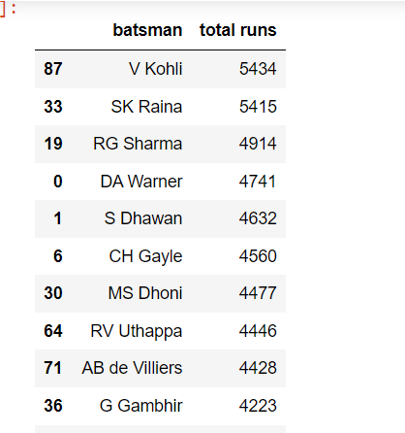

2.Top 10 bowlers in Ipl with more number of wickets:

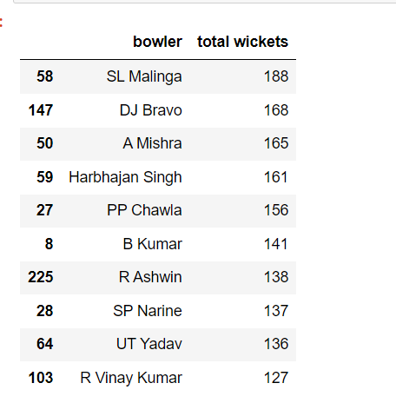

3.Top 10 players with highest number of sixes in IPL:

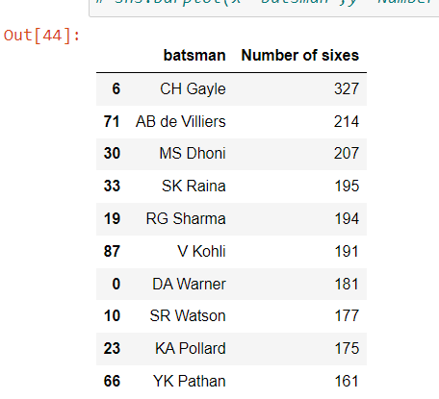

4.Top 10 player with more number of Boundaries in Ipl:

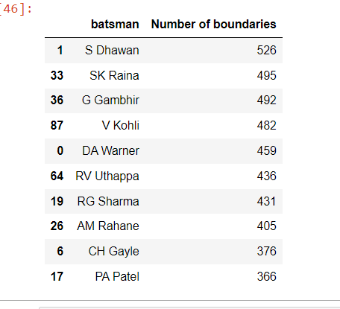

5.Top 5 highest run scorers for each season:

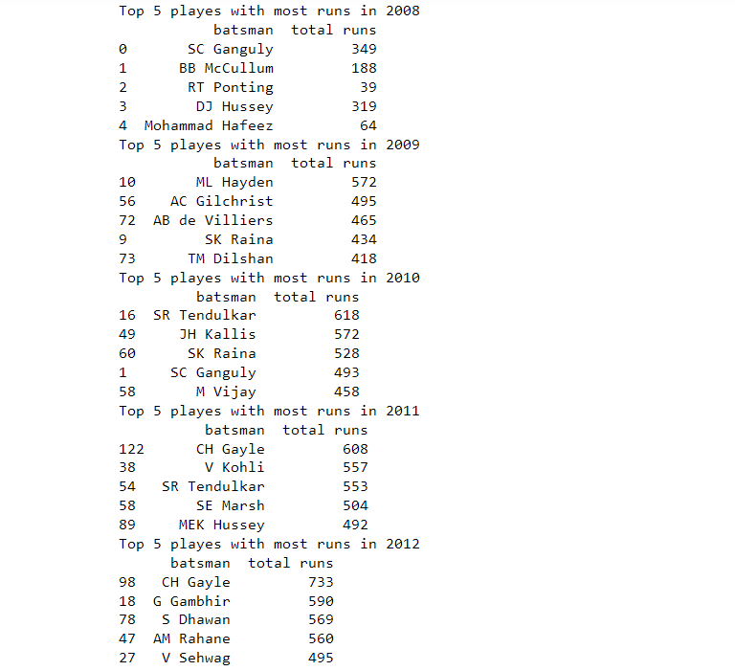

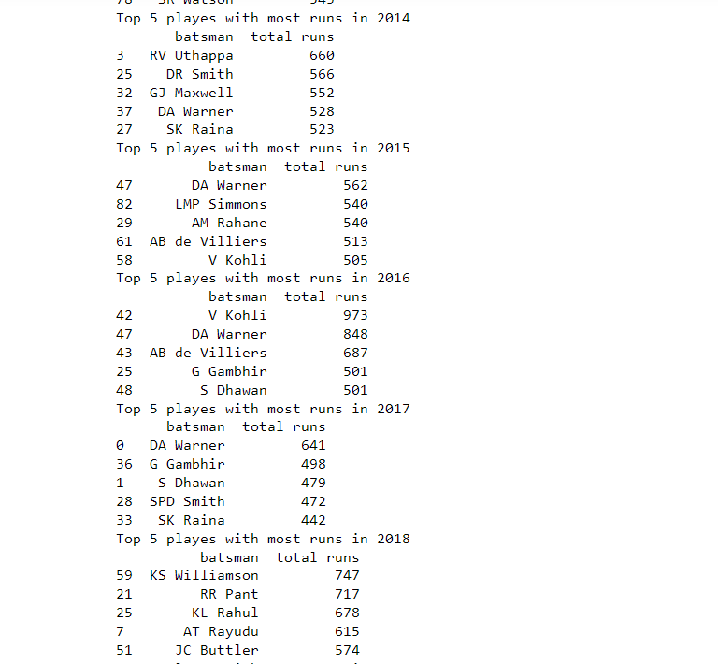



6.Since Virat Kohli is highest run scorer in IPL, strike rate for V kohli has been calculated for every season till 2019:

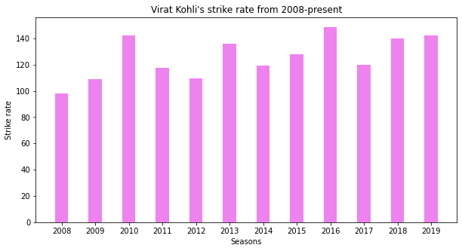

These are some of the player statistics calculated in this Project.

**Conclusion**: Following data has been cleaned, processed, analyzed, and several visualizations has about players and teams have been made successfully.